1 Corinthians 11: 23-26

For every [](http://www.google.ca/imgres?num=10&hl=en&biw=1229&bih=492&tbm=isch&tbnid=7NzHYGEyUjkZtM:&imgrefurl=http://www.zoho.com/invoice/&docid=ekNxcxSopIS6HM&imgurl=http://www.zoho.com/invoice/images/time-tracking-made-easy.png&w=420&h=380&ei=xS-EUIGYBMKCyAGphoHQBA&zoom=1&iact=hc&vpx=779&vpy=102&dur=1966&hovh=214&hovw=236&tx=109&ty=105&sig=104076961468085337823&page=2&tbnh=144&tbnw=137&start=11&ndsp=17&ved=1t:429,r:6,s:20,i:237)you [](http://www.google.ca/imgres?num=10&hl=en&biw=1229&bih=492&tbm=isch&tbnid=D5HHMShSdneXhM:&imgrefurl=http://www.care2.com/news/member/682890945/2620695&docid=2FOKlHHiCfQr0M&imgurl=http://dingo.care2.com/pictures/c2c/share/26/262/206/2620695_370.jpg&w=352&h=369&ei=9S-EUKm7BqLwyQGo4oGACg&zoom=1&iact=hc&vpx=187&vpy=126&dur=28&hovh=230&hovw=219&tx=140&ty=141&sig=104076961468085337823&page=1&tbnh=142&tbnw=121&start=0&ndsp=14&ved=1t:429,r:8,s:0,i:159) this  and  this

, 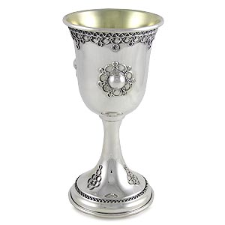 you are [](http://www.google.ca/imgres?hl=en&biw=1229&bih=492&tbm=isch&tbnid=-fTtJ-fk0AoiPM:&imgrefurl=http://snagmob.wordpress.com/&docid=_iYhURgBmY9f-M&imgurl=http://snagmob.files.wordpress.com/2011/05/announce.gif&w=185&h=186&ei=8DCEULyyEqy6yAGkvYHoCw&zoom=1&iact=hc&vpx=106&vpy=209&dur=1474&hovh=148&hovw=148&tx=111&ty=43&sig=104076961468085337823&page=1&tbnh=145&tbnw=145&start=0&ndsp=15&ved=1t:429,r:7,s:0,i:101)the Lord’s until He 